**RESTAURANT WEBSITE USING HTML**

**A PROJECT REPORT**

**Submitted by**

**SHREYASH SINGH**

**in partial fulfillment for the award of the degree of**

**BACHELOR OF TECHNOLOGY**

**IN COMPUTER SCIENCE AND ENGINEERING**



**Lovely Professional University, Punjab**

**Enrollment No – 12401174**

**NOVEMBER 2024**

**TABLE OF CONTENTS**

|  |  |  |
| --- | --- | --- |
| **S NO.** | **CHAPTER NAME** | **PAGE NO.** |
| **1.** | **Title Page** | **i** |
| **2.** | **Table of contents** | **ii** |
| **3.** | **Introduction to the project** | **iii** |
| **4.** | **Technology used** | **iv-v** |
| **5.** | **Workflow** | **vi-viii** |
| **6.** | **Project functionality** | **ix -xi** |
| **7.** | **Code Snippets** | **xii-xiii** |
| **8.** | **Screenshots** | **xiv-xv** |
| **9.** | **Conclusion** | **xvi** |
|  |  |  |

INTRODUCTION TO CULINARY PLEASURES

At [CULINARY PLEASURES], we believe that dining is more than just eating—it’s an experience that delights the senses, nourishes the soul, and creates lasting memories.

Our passion for exceptional cuisine drives us to craft dishes that celebrate the art of flavor, the beauty of presentation, and the warmth of hospitality. Each plate tells a story, blending the finest ingredients with a creative touch to take you on a journey of taste.

Whether you’re seeking a cozy dinner for two, a celebration with loved ones, or a moment to savor something truly special, we’re here to make every bite unforgettable.

Discover the joy of culinary pleasures with us—your table awaits!

Technologies Used in CULINARY PLEASURES

In developing Culinary Pleasures, I used several web technologies to create a functional and user-friendly website. Here are the main technologies used:

HTML5

• Used for structuring the web application

• Created the basic layout and elements

• Implemented the audio player using HTML5 audio features

• Added forms and input elements for user interaction

CSS3

• Styled the entire application to make it visually appealing

• Made the design responsive for different screen sizes

• Created animations for better user experience

• Used Flexbox and Grid for layout management

• Added hover effects and transitions for interactive elements

Workflow of Culinary Pleasures

Project Planning

1. Initial Research

• Studied different Website for RESTAURANT

• Listed essential features

• Planned the user interface

1. Design Phase

• Created rough sketches

• Designed the layout

• Chose colour scheme and fonts • Made the basic wireframe

Development Process

1. Setting Up

• Created project folder structure

• Set up HTML files

• Linked CSS

1. HTML Structure

• Built the main layout

• Made forms for user input

3. Styling with CSS

• Applied basic styles

• Made it responsive

• Added animations

Project Functionality

Core Features

1. Responsive Design:

Ensures seamless access across all devices,

from desktops to smartphones.

2. Dynamic Service Listings:

Comprehensive sections detailing services

such as corporate events, , product

launches, and more.

3. Event Gallery:

A vibrant collection of images and videos

showcasing past events for inspiration and

credibility.

4. Customizable Inquiry Forms:

Easy-to-use contact and booking forms for

clients to share their specific event

requirements.

5. Client Testimonials:

A dedicated section featuring feedback from

satisfied clients to build trust and authenticity.

Code Snippets

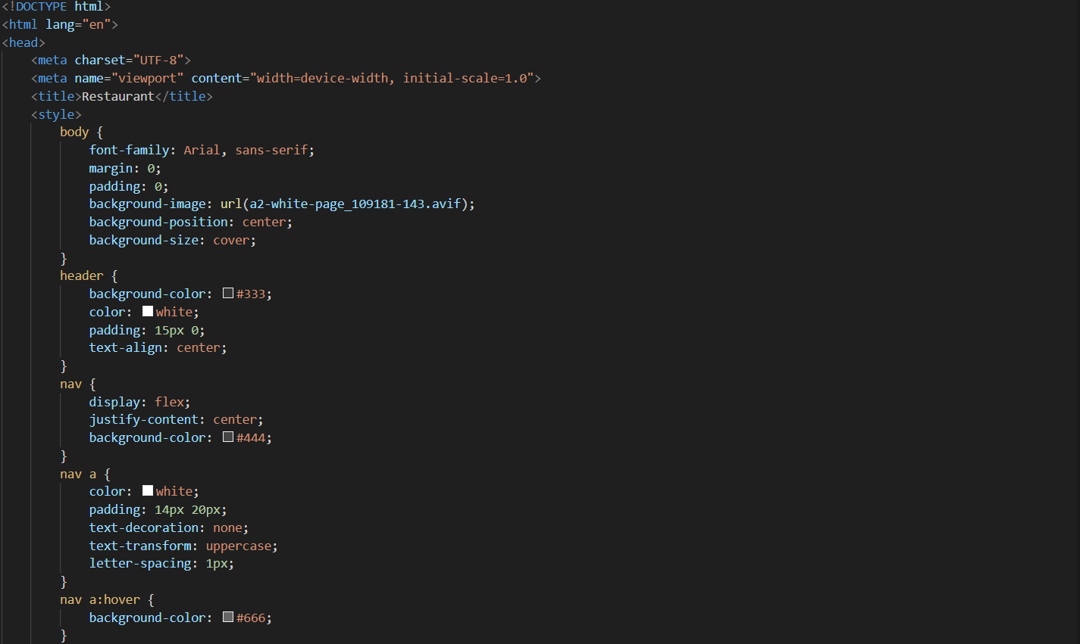

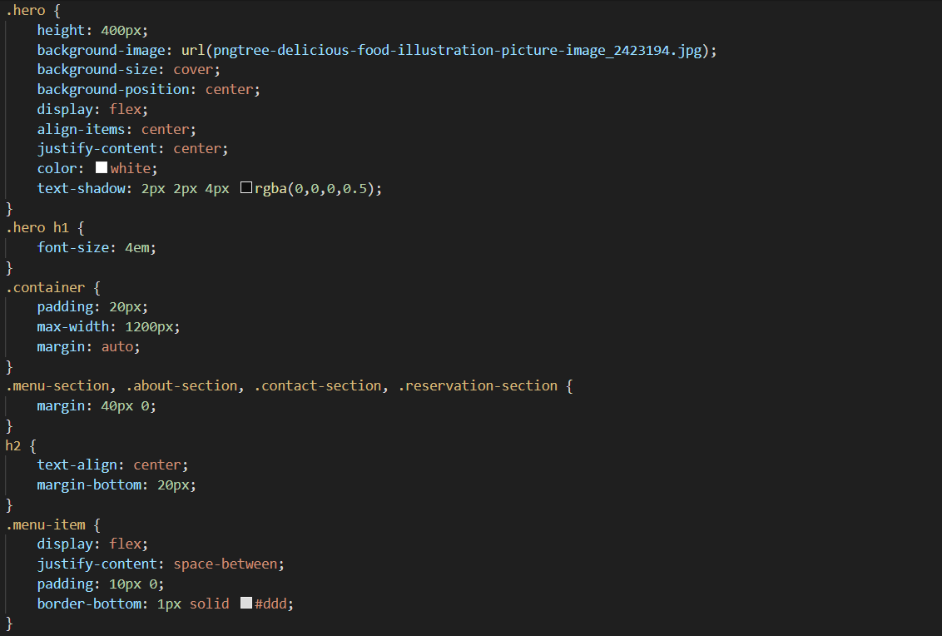

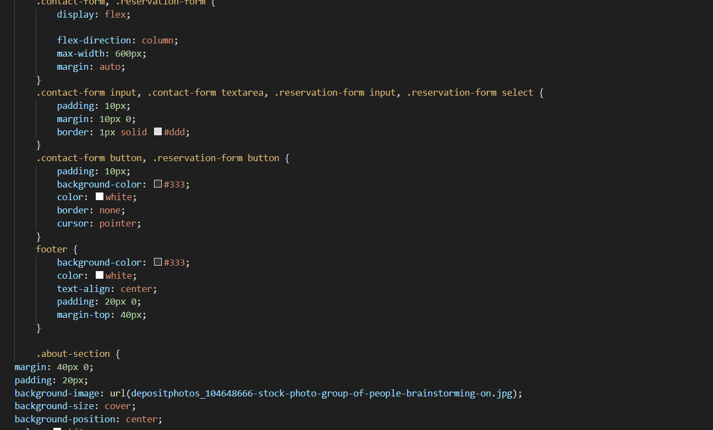

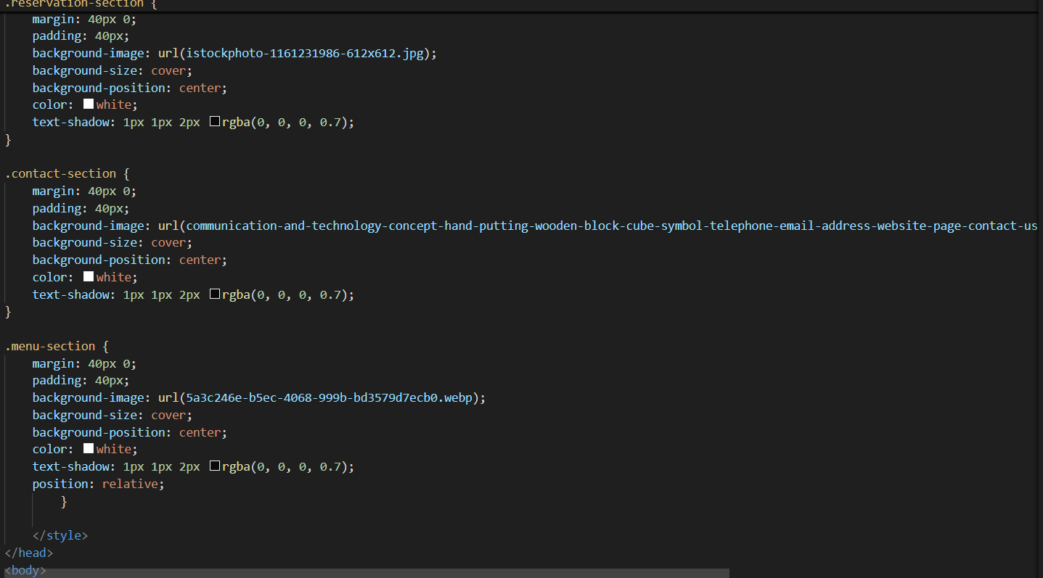

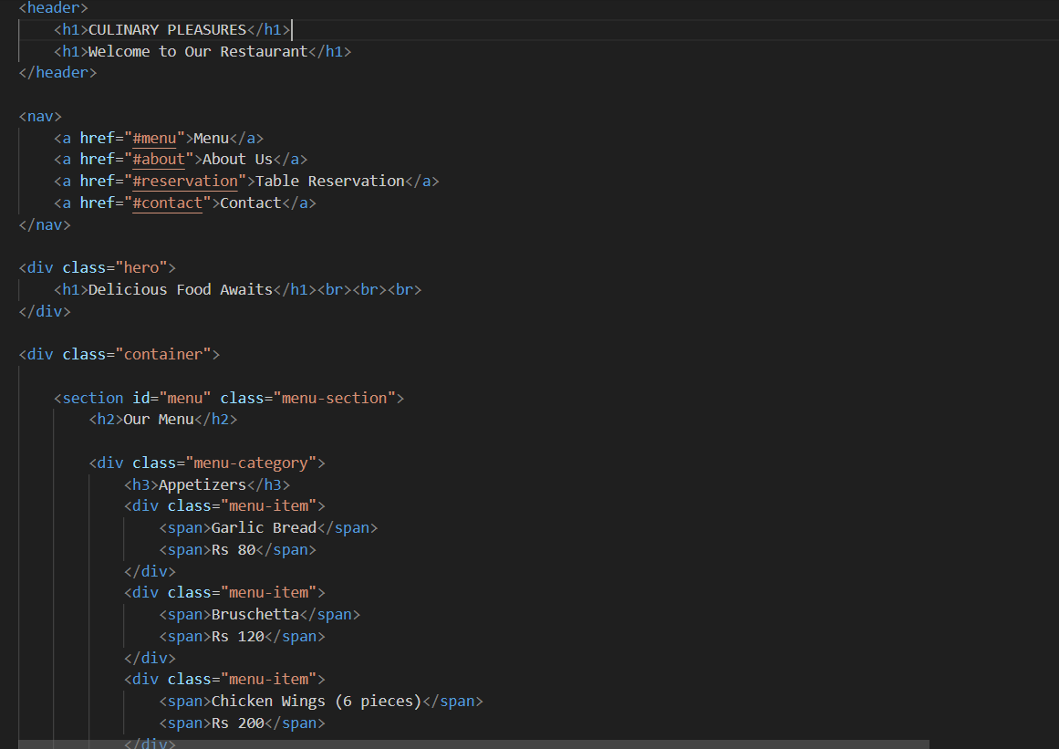

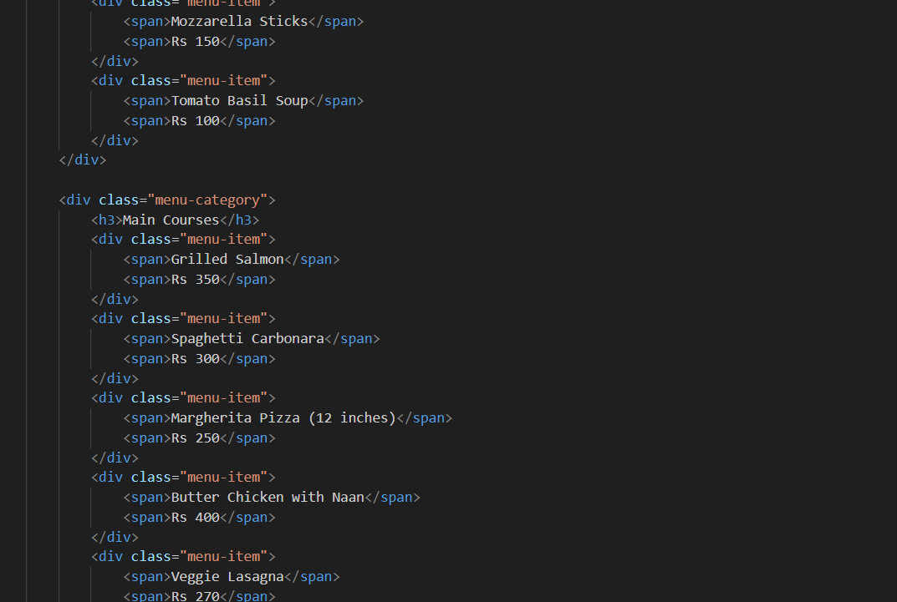

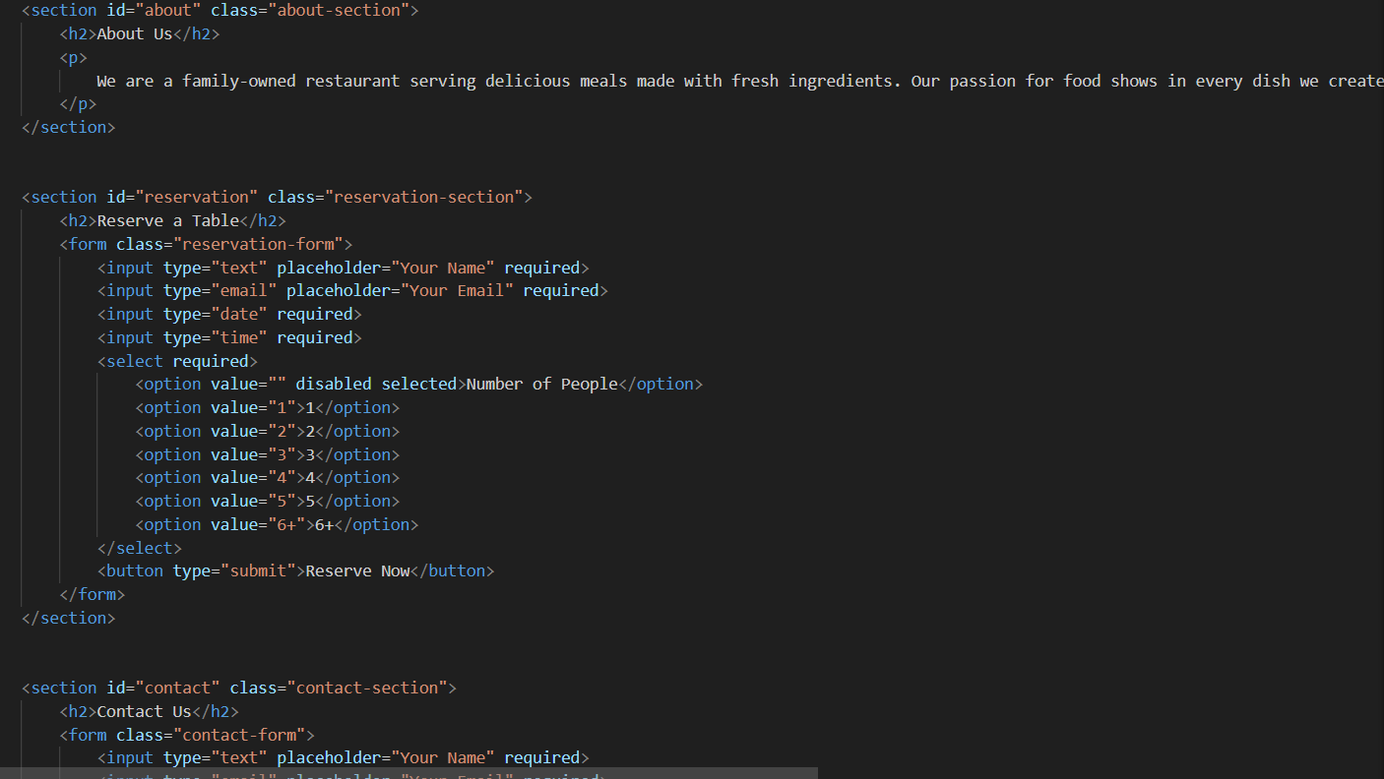

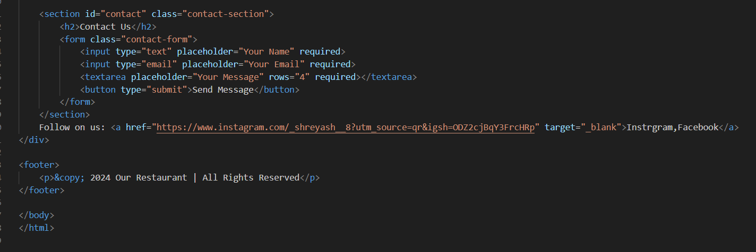

Screenshots

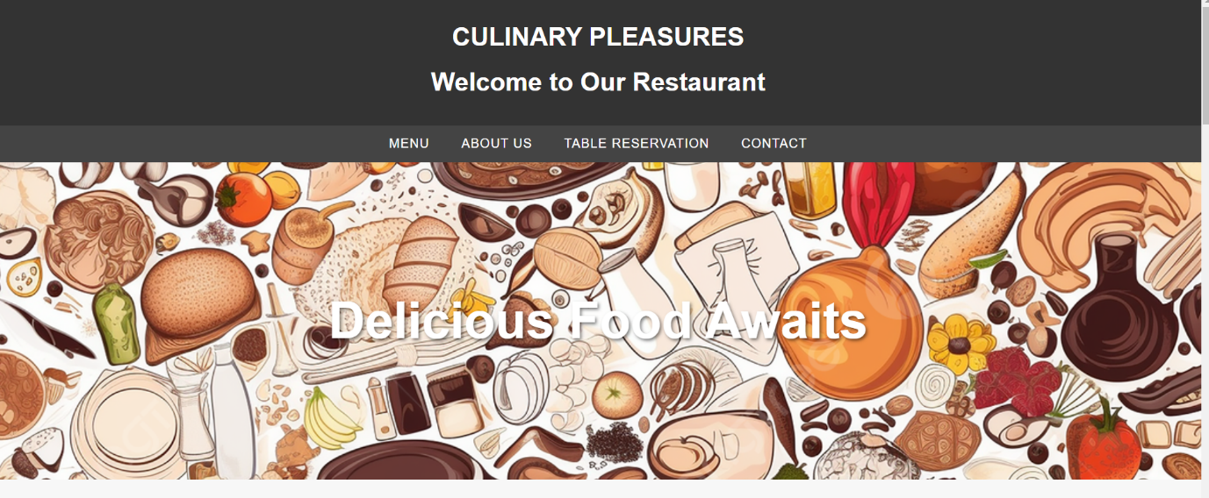

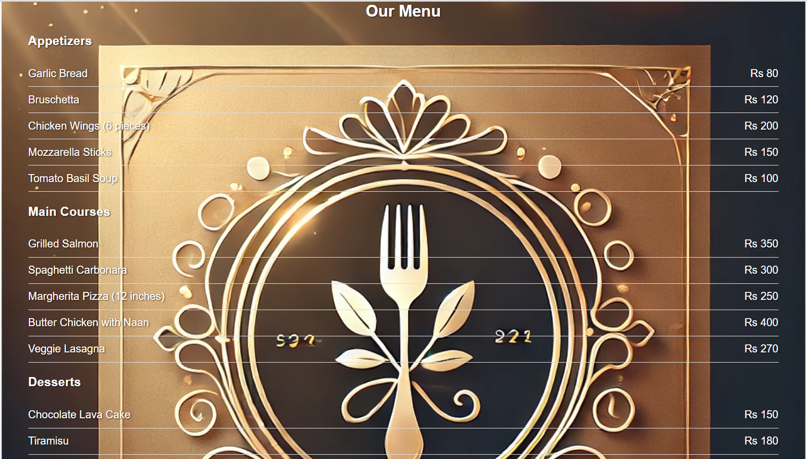

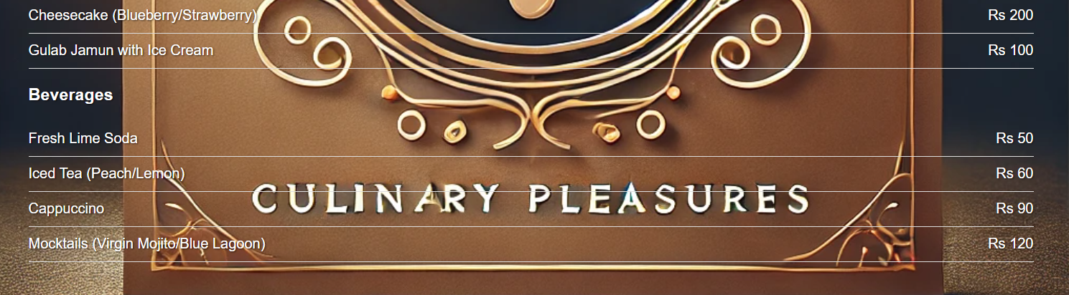

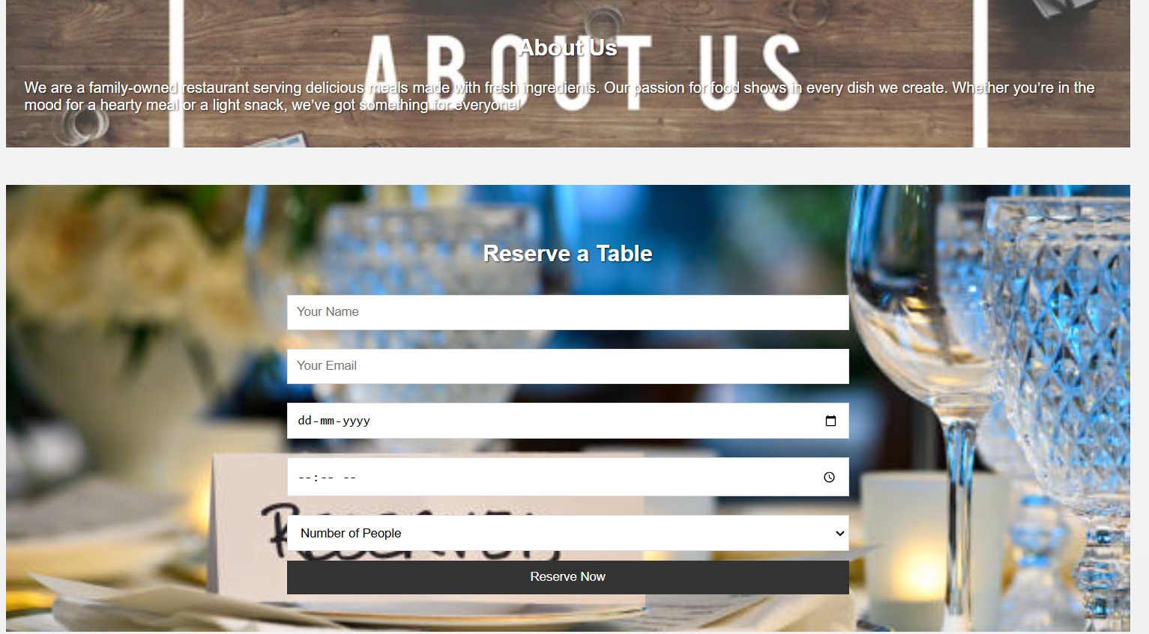

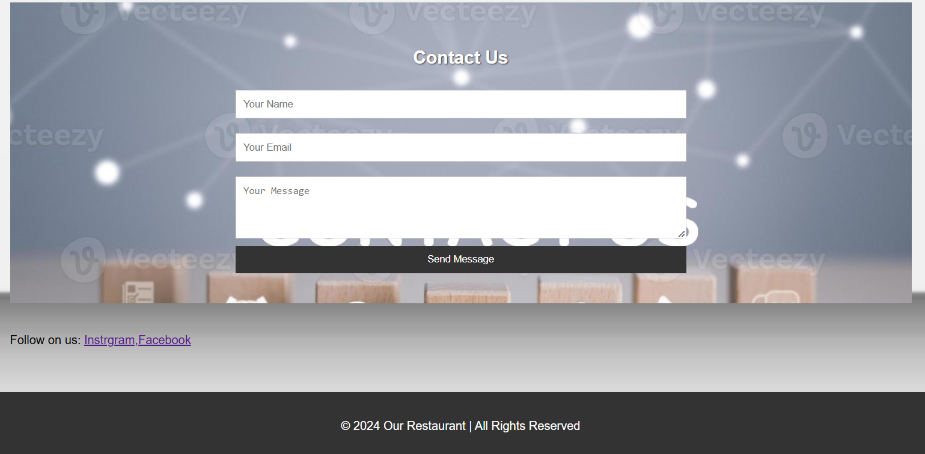

Conclusion

At Culinary Pleasures, we are more than just a restaurant; we are a celebration of flavor, ambiance, and exceptional service. Whether you’re here to explore bold new tastes, savor your favorite classics, or enjoy a memorable dining experience with loved ones, our doors are always open to welcome you.

From our thoughtfully curated menu to our warm and inviting atmosphere, every detail is designed to ensure your visit is nothing short of extraordinary. Thank you for choosing Culinary Pleasures — where every bite is a journey, and every meal is a story.

We look forward to serving you soon!

Your Table Awaits — Reserve Now!